
This was me when I first came to this world
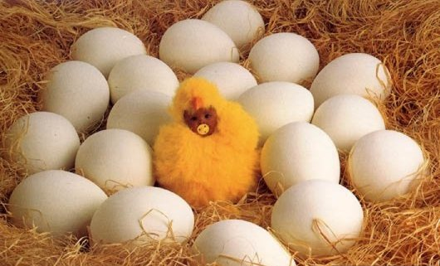

Then I grew a little bigger



As I grew up, I went through happiness

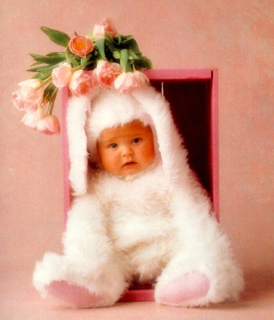
and I went through sadness



No matter what happened, my friends were always there to share!

D’AUTRES

SURPRISES

SUR
UMOOR.COM

